CSE112 Artificial Intelligence, Week 3

**Exercises and Tutorial Questions**

Q1. Define in your own words the following terms:

1. State
2. State space
3. Search tree
4. Search node
5. Goal
6. Action
7. Successor function
8. Branching factor

Q2. What are the stages of problem solving?

Q3. How do we formulate a problem?

Q4. What is a (optimal) solution to a problem?

Q5. What are two important properties of good abstraction?

Q6. What are the differences between world states and search nodes?

Q7. What is the difference between tree search and graph search?

Q8. In the problem-solving by search, **Fringe** (**frontier**) is often used to define a set of nodes not yet expanded, in indicated in the following figure:

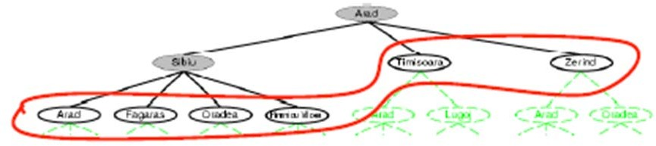

In another word, fringe is a first-in-first-out (FIFO) queue, i.e., new successors go at end of the queue. Then nodes from the fringe are called **leafs**. And the search algorithms can be described using the following operations over the fringe represented as a **queue**:

* MAKE-QUEUE(element,…)
* EMPTY?(queue)
* FIRST(queue)
* REMOVE-FIRST(queue)
* INSERT(element, queue)
* INSERT-ALL(elements, queue)

Discuss the differences between BFS and DFS with regard to the fringe/queue operations.

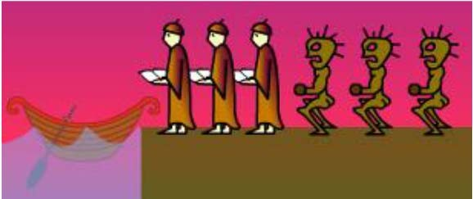Q9. Following is the famous “Missionaries & Cannibals” problem:

Three missionaries and three cannibals come to a river. A rowboat that seats two is available. If the cannibals ever outnumber the missionaries on either bank of the river, the missionaries will be eaten. (AIMA problem 3.9)

How shall they cross the river?

Discussion the appropriate formulation for the problem.

Q10. Which is a bigger problem for search algorithms – memory consumption or time efficiency?

Q11. For BFS, which one of the time complexity and space complexity is more serious?

Q12. With regard to time complexity and space complexity, compare the BFS and DFS strategies.

Q13. Suppose the goal state is 11. List the order in which nodes will be visited for

* + Breadth-first search
  + Depth-limited search with limit **3**
  + 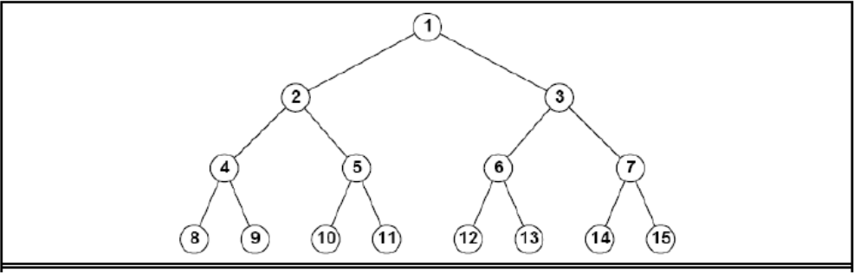terative deepening search:

Q.14 Water jug is a classical formal problem, and is generally stated as below.

Water jug is a classical formal problem, and is generally stated as below.

Assume that you have two jugs with no measure markings, 4-gallons jug (Jug A) and 3-gallons jug (Jug B). We have an infinite supply of water to fill the jugs, we can also pour away water to empty the jug. Our task is to measure exactly 2 gallons of water in the 4 gallons Jug.

1. Formalise the Water jug problem in terms of its goal, states, operators and path cost.
2. Use depth first search to solve the problem.
3. Is it a good idea to avoid repeated states? Why?
4. Write a prolog program to solve it （optional）.